Read the following scenario and answer the questions below.
“The system under discussion is a small Mail Order Catalogue System that
allows people to shop from home. When a customer receives the catalogue and
wants to buy something, he can telephone, fax or email his order to the
company. The company gets the order and sends the goods and an invoice.
When the customer receives the goods with a delivery note, he sends payment
and receive a receipt for his payment.”

2) Draw a Context-level Data Flow Diagram for the Mail Order Catalogue System.

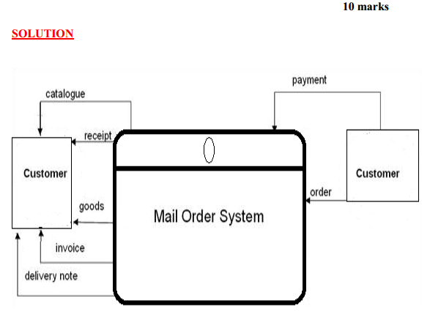

Draw an Entity Relationship Diagram for the Mail Order Catalogue System.
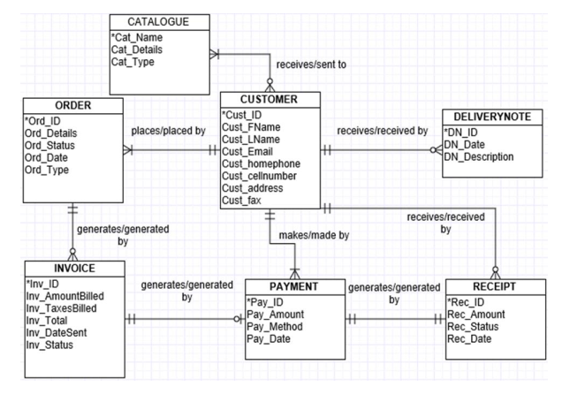
Question: Read the following case study and draw an ER diagram by
identifying all the entities, attributes and their relationships.
The following is a description of some data requirements for a chain of
pharmacies. Draw the appropriate entity-relationship (E-R) diagram.
(a) A pharmaceutical company manufactures one or more drugs, and each
drug is manufactured and marketed by exactly one pharmaceutical company.
The name of each Pharmaceutical company is unique. The other attributes of
company are its address, PO Box, Telephone Number, Email address, Fax.
(b) Drugs are sold in pharmacies. Each pharmacy has a unique identification.
Every pharmacy sells one or more drugs, but some pharmacies do not sell
every drug. The other details of pharmacy include Pharmacy Name, Telephone,
Fax and PO Box.
(c) Drug sales must be recorded by prescription, which are kept as a record by
the pharmacy. A prescription clearly identifies the drug, name Doctor ID, and
patient ID, as well as the date it is filled. A prescription is identified by its
Prescription number.
(d) Doctors prescribe drugs for patients. A doctor can prescribe one or
more drugs for a patient and a patient can get one or more prescriptions, but a
prescription is written by only one doctor. A doctor has his own medical ID and
has his name and telephone number.
Ans: The ER model for question is derived from the following larger ER
diagram. You can assess the correctness of answer by checking this model.
Ans: This is complete model of given question. However, students don’t
need to write PK with the primary keys or write type of relationship. If
they show sufficient attributes and proper relationships, answer should be
considered correct.
